Intelligent Closed-Loop Process Control for Metal Additive Manufacturing via Reinforcement Learning-Based AI Agents

Highlight Panel
Objectives
The core objective of this project is to develop an innovative reinforcement learning (RL)-based closed-loop control system for laser-based additive manufacturing (LAM), enabling real-time, adaptive parameter adjustments under non-linear, time-varying dynamics to minimise defects like porosity, cracking, and melt pool instabilities.
To realise this vision, the following objectives will be pursued:
- Establish a Partially Observable Markov Decision Process (POMDP) framework for LAM control, with a reward function optimising key defect metrics (e.g., reduce porosity and residual stress). This will leverage a dynamic Bayesian network & graph neural network with variational autoencoder (DBN-GNN-VAE) approach to fuse multi-modal sensor data (thermal, optical, acoustic) into a probabilistic state space and define an action space over parameters (e.g., laser power, scan speed), capturing LAM’s non-linear dynamics.
- Design and train RL agents within a physics-informed digital twin, employing the POMDP framework and scalable RL algorithms (e.g., PPO, TD3), with validation on physical LAM systems to ensure robust, adaptive control for complex manufacturing.
- Benchmark the proposed RL system (with DBN-GNN-VAE fusion and POMDP formalisation) against traditional PID and supervised learning methods, using in-situ experiments across materials and geometries, assessing reductions in porosity (via XCT), stability, and cracks (via SEM) for superior performance.
- Enhance generalisation through a meta-learning framework using Model-Agnostic Meta-Learning (MAML) and few-shot learning, through rigorous validation of scalability across alloys, geometries, and LAM platforms with TWI, supported by ISIS Neutron Source analysis, for long-term industrial impact.

Summary
Laser-based additive manufacturing (LAM) is reshaping high-value industries—such as aerospace, energy, and defence—by enabling the creation of complex, lightweight metal components with unmatched material efficiency. Yet, its potential remains curtailed by persistent defects like porosity (3–5%) and cracking, driven by thermal instabilities during printing. These flaws compromise structural integrity, delay certification for safety-critical applications, and force manufacturers into costly, labour-intensive trial-and-error optimisation, undermining scalability and industrial uptake.
Current LAM systems rely on static parameter settings and rudimentary feedback loops, such as PID controllers, which falter against the process’s non-linear, time-varying dynamics. This project introduces a groundbreaking shift: real-time, adaptive control powered by reinforcement learning (RL). By fusing multi-modal sensor data—thermal, optical, and acoustic—into a probabilistic state representation, underpinned by an innovative sensor probabilistic fusion approach, an RL agent will dynamically tune parameters like laser power and scan speed, suppressing defects and enhancing reliability across diverse materials and geometries.
The research will achieve four transformative outcomes:
- A physics-informed digital twin, blending simulations and sensor models, to train the RL agent safely and efficiently.
- An RL control system that interprets fused sensor signals, targeting porosity below 2% and reducing residual stress at least 15% in real time.
- Comprehensive benchmarking against PID and supervised learning, proving superior defect mitigation and process consistency.
- Validation of scalability and transferability across alloys, shapes, and machines, in collaboration with industry leaders like TWI, ensuring robust applicability beyond lab-scale demonstrators.
Aligned with EPSRC’s Digital Manufacturing and Net Zero Manufacturing themes, this project pioneers AI-driven, sustainable production. It promises to slash waste, cut costs, and bolster UK competitiveness in high-value manufacturing, cementing national leadership in intelligent, low-carbon industrial technologies.

Academic Beneficiaries
This research bridges manufacturing science, machine learning, and control engineering, delivering transformative benefits to academic communities by advancing foundational methods in intelligent process control, laser-based additive manufacturing (LAM), and data-driven optimisation. It introduces a reinforcement learning (RL)-based closed-loop control framework, tailored for real-time defect mitigation in metal AM, enriching scholarly understanding of adaptive, AI-driven manufacturing systems.
By framing LAM control within a Partially Observable Markov Decision Process (POMDP) and integrating multi-modal sensing (thermal, optical, acoustic), the project offers innovative tools and methods for researchers investigating adaptive manufacturing. The developed digital twin and sensor fusion techniques will serve as valuable resources for scholars in sim-to-real transfer, industrial RL, and smart manufacturing systems. These also support advancements in foundational theories of adaptive control and practical smart manufacturing applications.
This project will empower academic researchers across key fields:
- Control systems and machine learning experts will benefit from a pioneering RL application in high-frequency, multi-variable manufacturing, supported by open-access datasets, reward structures, and trained models.
- Materials and manufacturing scientists will gain deeper understanding of defect dynamics under varying conditions, enhanced by in-situ sensing and microstructural insights.
- Digital twin and intelligent control researchers will utilise the project’s open-source simulation and sensing platforms as a benchmark for advancing smart manufacturing technologies.
- Findings will be disseminated via international journals, conferences, and open-access platforms. Collaborations with TWI and ISIS will ensure academic excellence and industrial relevance, shaping new standards in AI-driven manufacturing research.

1. EXPERTISE AND TRACK RECORD OF THE TEAM

1.1 Representative Publications
TBC

1.2 Experience in Supervision and Research Training
TBC

1.3 Project Partners
TBC

1.4 Facilities
TBC

2. DESCRIPTION OF THE PROPOSED RESEARCH

2.1 Background
The evolution of advanced manufacturing, vital to UK industrial innovation, demands technologies enhancing production efficiency and material versatility. Laser-based additive manufacturing (LAM), particularly laser-directed energy deposition (LDED), excels in fabricating large-scale metallic components with complex geometries, serving as a cornerstone for cutting-edge applications in aerospace, energy, and defence. Nonetheless, challenges in process stability and defect mitigation—evidenced by 3–5% porosity and crack formation—undermine fatigue performance and certification, compounded by labour-intensive optimisation requiring dozens of trials per material-geometry pairing, thus restricting scalability and broader industrial integration.
Conventional closed-loop control, anchored by proportional-integral-derivative (PID) controllers, adjusts parameters such as laser power based on real-time error feedback, offering modest gains in single-variable regulation. However, PID proves inadequate for LAM’s non-linear, time-varying dynamics, including thermal gradients and irregular geometries. Recent efforts using supervised learning, while improving defect prediction, fall short of delivering adaptive, real-time control. Emerging theoretical frameworks, including the Bayesian networks (DBNs) and graph neural networks with variational autoencoders (GNN-VAE) framework for probabilistic multi-modal state fusion and the formalisation of LAM control as a Partially Observable Markov Decision Process (POMDP) with multi-objective optimisation, address these shortcomings with dynamic, data-driven approaches. While stochastic sandbox environments offer API-like full-state observability, industrial LAM processes lack such direct, noise-free data interfaces, presenting a key challenge in translating closed-loop control from digital twins to physical systems. This gap underscores the need for robust sensor fusion and adaptive control strategies, as addressed in this proposal.
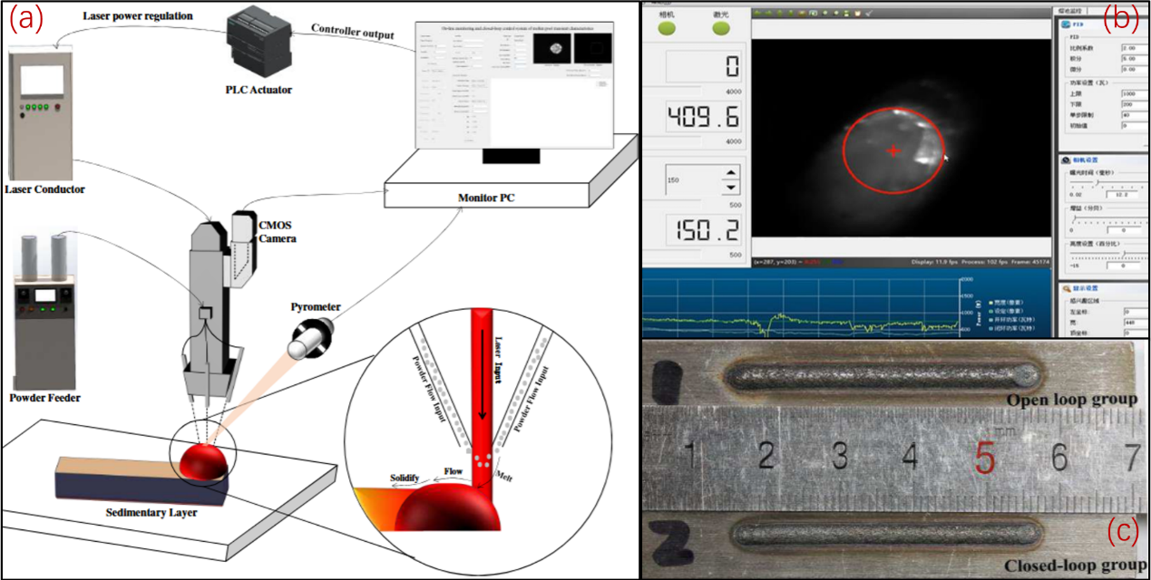
Figure 1. PID-based closed-loop control system and process results in LDED. (a) Control architecture with pyrometer, CMOS camera and PLC for real-time laser regulation. (b) Industrial interface showing melt pool thermal feedback.(c) Deposition tracks: open-loop vs closed-loop PID control.
Reinforcement learning (RL) represents a transformative methodology, optimising control policies through environment interaction and reward signals without reliance on pre-labelled data. The proposed project harnesses a DBN-GNN-VAE approach for multi-modal sensor integration, a POMDP framework for policy optimisation, and meta-learning with few-shot learning to systematically enhance generalisation across diverse LAM conditions. These advancements overcome the limitations of PID and supervised methods, paving the way for robust, adaptive control theories applicable to complex, high-value manufacturing systems.

2.2 Contribution to Knowledge
The proposed research will deliver the following contributions to knowledge as
- Development of a RL-based control framework for LAM, integrating a DBN-GNN-VAE framework for multi-modal probabilistic state representation (thermal, optical, acoustic), establishing a rigorous theoretical foundation for real-time defect suppression.
- Formalisation of closed-loop LAM control as a Partially Observable Markov Decision Process (POMDP), rigorously capturing non-linear, time-varying dynamics. This enables principled multi-objective optimisation of control policies, validated within a physics-informed digital twin environment.
- Advancement of meta-learning and few-shot learning frameworks to systematically improve RL generalisation across diverse LAM conditions, underpinning robust adaptive control theories.
To maximise impact, results will be disseminated through conferences (e.g., IEEE CASE, ICRA, CIRP) and journals (e.g., Additive Manufacturing, Journal of Manufacturing Science and Engineering). Open-access code, datasets, and documentation will support the research community, shared via collaborations with The Welding Institute (TWI) and ISIS Neutron and Muon Source, ensuring empirical grounding of the theoretical developments and enabling future extensions by the broader research community.

2.3 Nation Importance
The UK’s Ten-Year Industrial Strategy and National AI Strategy prioritise digital transformation in high-value manufacturing, targeting productivity, waste reduction, and accelerated net-zero transition through automation and AI. Reinforcement learning (RL)-based control for LAM supports these ambitions by enabling real-time, adaptive optimisation, reducing energy use and enhancing material efficiency, establishing a foundation for sustainable AI-driven manufacturing systems. Aligned with EPSRC’s endorsed themes of Digital Manufacturing, Transforming Foundation Industries, and Net Zero Manufacturing, this research leverages digital technologies to innovate manufacturing processes and supports the transformation of foundation industries such as aerospace and energy towards net-zero goals.
Despite strengths in digital infrastructure, including TWI and High Value Manufacturing Catapult, and academic research, the UK remains underdeveloped in RL-based LAM control relative to North America and East Asia, which largely rely on PID and model-driven systems struggling with non-linear dynamics. This gap limits scalability and quality assurance, hindering UK competitiveness across strategic sectors such as aerospace, energy, and defence, and slowing progress towards automated, net-zero manufacturing. The proposed RL framework addresses this by developing theoretical advancements in adaptive, data-driven control, reducing reliance on labour-intensive process tuning and manual inspections. It fosters high-skill job creation and knowledge transfer, positioning the UK as a leader in AI-driven sustainable manufacturing.

2.4 Research Hypothesis and Objectives
The project targets laser-based additive manufacturing (LAM) to address defect formation and process instability. It advances a reinforcement learning (RL)-based closed-loop control framework through theoretical innovation. The hypothesis posits that a DBN-GNN-VAE framework, fusing thermal, visual, and acoustic sensor data, can enable a Partially Observable Markov Decision Process (POMDP) to model dynamic LAM processes. This RL approach, surpassing traditional PID and supervised methods, learns adaptive policies that generalise across varying alloys and geometries, without reliance on pre-labelled data, to handle non-linear dynamics and multi-objective trade-offs (e.g., porosity <2%, residual stress reducing 15%).
To achieve this, the project pursues the following objectives as
- Develop a DBN-GNN-VAE framework to theoretically fuse multi-modal sensor data into a probabilistic state representation, validated with TWI datasets, supporting WP2’s POMDP modelling.
- Formulate a POMDP-based RL framework with multi-objective optimization, training agents via a physics-informed digital twin, and ensuring transparent policy documentation.
- Advance meta-learning and few-shot learning theories to enhance RL generalization across LAM tasks, validated with >85% success in simulated scenarios, and releasing open-access models.
This framework establishes new theoretical foundations for intelligent LAM control, reinforcing the UK’s leadership in AI-driven sustainable manufacturing.

2.5 Program and Methodology
This program outlines a comprehensive, 36-month research initiative that synergises advanced manufacturing, artificial intelligence, and control engineering to revolutionise LAM through a RL-based closed-loop control framework. Structured across four interdependent work packages, the project integrates multi-modal sensing, digital twin simulation, RL agent development, and industrial deployment to address the critical challenges of defect suppression, process stability, and scalability in metal AM.

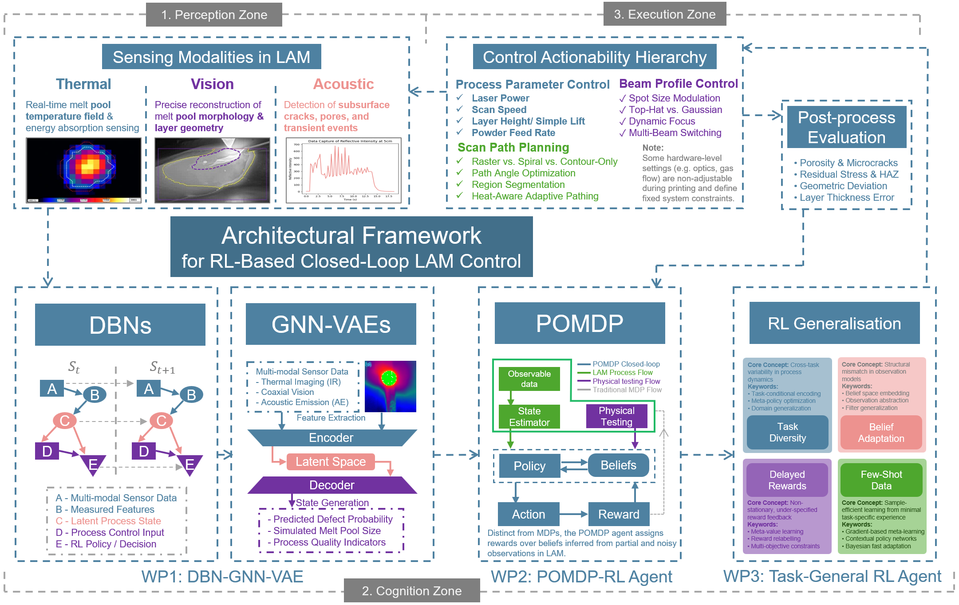

WP1: Multi-Modal State Representation and Sensor Fusion for Dynamic Laser Additive Manufacturing Environments
Objective
Develop a probabilistic DBN-GNN-VAE framework for real-time fusion of thermal, visual, and acoustic data, enabling robust probabilistic state estimation for RL-based control in dynamic LAM environments.
Description
This work package integrates high-resolution infrared cameras (thermal gradients), coaxial vision systems (melt pool geometry), and photodiodes/microphones (plume/acoustic emissions) to capture the complex, dynamic LAM process. It addresses LAM-specific challenges: material state uncertainties (e.g., alloy variations), thermal-mechanical coupling, and transient melt pool dynamics (e.g., instabilities, spatter, cracking precursors). A probabilistic framework combining dynamic Bayesian networks (DBN) and graph neural networks with variational autoencoders (GNN-VAE) fuses asynchronous, noisy sensor data into a compact, probabilistic state estimate, capturing temporal dependencies and multi-modal interactions. This state estimate, sampled at ≥2 kHz, serves as the latent representation for the POMDP state space in WP2, enabling robust RL control under partial observability. Unlike single-modality sensing (e.g., thermal-only) or conventional fusion (e.g., Kalman filters, CNN-based methods), the DBN-GNN-VAE approach models temporal and multi-modal interactions probabilistically, ensuring high-fidelity state representation for RL control. Sub-millisecond synchronization and dimensionality reduction optimize real-time performance (<1 ms latency). Validation leverages simulated LAM environments and real-world datasets from industrial partner TWI, with defect detection supported by ISIS Neutron and Muon Source’s advanced imaging.
Tasks:
- Task 1.1: Develop a DBN model to capture temporal dependencies in thermal, visual, and acoustic data, addressing LAM’s thermal-mechanical coupling and material uncertainties to support probabilistic state estimation. (Months 1–6)
- Task 1.2: Implement GNN-VAE fusion algorithms for asynchronous, high-dimensional sensor streams, optimizing for real-time computation (<1 ms latency) and generating a compact latent representation for POMDP modeling in WP2. (Months 6–12)
- Task 1.3: Validate in simulated LAM environments (e.g., melt pool transient simulations), evaluating state estimation accuracy (MSE <5%) and defect precursor identification (e.g., porosity, cracks, >95% accuracy). (Months 12–15)
- Task 1.4: Test on real-world LAM datasets from TWI, with defect validation via ISIS Neutron and Muon Source imaging, ensuring robustness to noise and missing data (<10% performance degradation). (Months 15–18)
Justification
Robust state estimation is critical for RL-based LAM control, where traditional single-modality (e.g., thermal-only) or conventional fusion methods (e.g., Kalman filters, CNN-based methods) are inadequate in modelling complex, transient dynamics such as melt pool instabilities and multi-modal interactions. The DBN-GNN-VAE framework explicitly models temporal dependencies and multi-modal interactions probabilistically, achieving >95% defect precursor accuracy (e.g., porosity, cracks). This enables precise, real-time state estimation for WP2’s POMDP modelling, supporting robust and generalizable RL control under realistic LAM conditions.
Deliverables
- Calibrated multi-modal sensor suite for LAM (Month 6).
- DBN-GNN-VAE sensor fusion pipeline for real-time state vectors (open-source release with documentation, supporting LAM research community, Month 12).
- Dataset of aligned sensor signals with annotated defect events (e.g., porosity, cracks) for WP2/WP3 benchmarking (Month 15).
- Validation report on simulated and industrial performance, including accuracy and defect metrics (Month 18).
- Journal paper on LAM defect detection via multi-modal fusion, submitted to Additive Manufacturing or IEEE Transactions on Industrial Informatics (Month 18).
Dependencies
This WP directly defines the probabilistic state space for WP2’s POMDP modelling and RL training, and provides real-time, high-fidelity state vectors critical for WP3’s generalization and robustness assessments under realistic LAM manufacturing conditions.

WP2: Tailored POMDP Frameworks and Multi-Objective RL for LAM Decision-Making
Objective
To develop a reinforcement learning (RL)-based control agent capable of adaptive, real-time process regulation in laser-based additive manufacturing (LAM), trained through interaction with a physics-informed digital twin under a formal Markov Decision Process (MDP) framework.
This work package constructs the core intelligent control module of the project by formulating the closed-loop LAM control task as a Partially Observable Markov Decision Process (POMDP) and developing a reinforcement learning agent capable of mapping historical multi-modal observations to optimal process parameter actions.
Description
This work package constructs the core intelligent control module of the project by formulating the closed-loop LAM control task as a Markov Decision Process (MDP) and developing a reinforcement learning agent capable of mapping fused sensor states to optimal process parameter actions.
The MDP formulation is defined as
$$M=\left(S,A,O,P,O_{p},R,γ\right)$$
And where
- $S$: State space, comprising a compact latent representation estimated from historical observations $o_{t}$using the DBN-GNN-VAE framework (WP1). This framework fuses asynchronous, noisy multi-modal sensor data into a probabilistic state estimate, capturing temporal dependencies and material uncertainties for robust RL-based control.
- $A$: Action space, including controllable parameters such as laser power 𝑃, scan speed 𝑣, and wire feed rate 𝑓.
- $O$: Observation space, reflecting partial observability due to sensor noise and material uncertainties (e.g., alloy variations, melt pool instabilities).
- $P$(𝑠_{𝑡+1}∣𝑠_{𝑡},𝑎_{𝑡}): Stochastic transitions modelling LAM dynamics (thermal-material interactions, deposition history).
- $O_{p}(o_{t}|s_{t},a_{t})$: Observation probabilities capturing sensor uncertainties.
- $R$(𝑠_{𝑡},𝑎_{𝑡}): Multi-objective reward function, balancing porosity (<2%), residual stress (<100 MPa), and dimensional accuracy (±0.1 mm) via Pareto optimization.
- $γ$: Discount factor (0.95–0.99)).
The goal is to learn an optimal control policy $π^{*}:O→A$ that maximises expected cumulative reward as
$$π^{*}=\arg{\max_{π}{E}}\left[\sum_{t=0}^{∞}{γ^{t}R\left(s_{t},a_{t}\right)}\right]$$
where a physics-informed digital twin, integrating reduced-order thermal models, empirical material-energy relationships, and WP1’s sensor data, simulates LAM dynamics with high fidelity. To ensure robust sim-to-real transfer, domain randomization is applied across two key axes: (1) sensor-level discrepancies, including thermal conductivity (±10%), sensor drift (±20%), and noise injection across thermal, visual, and acoustic modalities; and (2) actuator-level discrepancies, including laser power fluctuations (±10%), scan speed variations (±5%), and wire feed rate inaccuracies (±5%). Stochastic noise injection further improves robustness to real-world disturbances. RL algorithms—Proximal Policy Optimization (PPO), Twin Delayed DDPG (TD3), and Soft Actor-Critic (SAC)—are trained using curriculum learning, progressing from simple linear tracks to complex geometries. Validation leverages industrial testbeds at TWI and defect characterization from ISIS Neutron and Muon Source to ensure performance under realistic LAM conditions.
Tasks:
- Task 2.1: Formulate a POMDP for LAM, integrating WP1’s state representations to model uncertainties (e.g., melt pool dynamics, material defects). (Months 6–12)
- Task 2.2: Develop RL algorithms (PPO, TD3, SAC) tailored for LAM’s high-dimensional POMDP, optimizing convergence with curriculum learning. (Months 12–18)
- Task 2.3: Design multi-objective RL algorithms using Pareto optimization to balance porosity (<2%), residual stress (<100 MPa), and dimensional accuracy (±0.1 mm). (Months 18–22)
- Task 2.4: Validate agents in simulated and industrial testbeds (with TWI and ISIS Neutron and Muon Source), with ≥30 trials achieving >90% simultaneous compliance with porosity (<2%), residual stress (<100 MPa), and dimensional accuracy (±0.1 mm). (Months 22–24)
Key Technical Contributions
- Tailored POMDP formalization for LAM, capturing partial observability and dynamic uncertainties, surpassing traditional PID controllers (limited in handling multi-objective trade-offs) and single-objective RL (unable to resolve conflicting quality metrics).
- Multi-objective RL framework optimizing porosity (<2%), residual stress (<100 MPa), and dimensional accuracy (±0.1 mm) via Pareto optimization.
- Physics-informed digital twin with domain randomization (e.g., thermal conductivity, powder flow) for robust sim-to-real transfer.
- Scalable RL algorithms (PPO, TD3, SAC) with curriculum learning for complex LAM tasks.
- Industrial validation pipeline leveraging TWI datasets and ISIS Neutron and Muon Source defect analysis.
Deliverables
- Physics-informed LAM digital twin with real-time control interface (Month 12).
- Multi-objective RL agents (PPO, TD3, SAC), open-sourced with documentation for LAM research community (Month 18).
- Benchmark datasets and trained models for WP3 evaluation (Month 20).
- Validation report on simulated and industrial performance, including multi-objective metrics (Month 24).
- Conference paper on multi-objective POMDP-RL for LAM, submitted to CIRP Conference on Manufacturing Systems or IROS (Month 24).
Dependencies
Utilizes WP1’s multi-modal state representation for POMDP modelling. Provides trained RL agents (policies, hyperparameters) and validated digital twin (with randomization protocols), enabling WP3’s robustness and generalization testing.

WP3: Generalization and Robustness for RL-Based LAM Control
Objective
Develop meta-learning and few-shot learning frameworks for robust, rapid industry-relevant RL-based LAM control generalization across diverse materials and geometries.
Description
This work package advances the generalization and robustness of WP2’s POMDP-based multi-objective RL agents for laser additive manufacturing (LAM) through meta-learning and few-shot learning, addressing fundamental challenges in adapting to new tasks (e.g., new alloys, complex geometries) under dynamic conditions (e.g., melt pool instabilities, sensor noise). Meta-learning, using Model-Agnostic Meta-Learning (MAML), optimizes RL policies for rapid adaptation. MAML specifically enables rapid policy adaptation from a minimal number of LAM task trials, overcoming conventional RL’s requirement for extensive retraining as
$$θ^{*}=\arg{\min_{θ}{\sum_{T_{i}∼p\left(T\right)}{L_{T_{i}}\left(θ-α∇_{θ}L_{T_{i}}\left(θ\right)\right)}}}$$
Where
- $θ$: Initial RL policy parameters.
- $T_{i}∼p\left(T\right)$: Task distribution (e.g., printing with varying alloys, lattice structures, or sensor configurations).
- $L_{T_{i}}$: Task-specific loss, measuring deviation from multi-objective criteria (porosity <2%, residual stress <100 MPa, dimensional accuracy ±0.1 mm).
- $α$: Adaptation step size.
Few-shot learning enables adaptation with k-shot data (k≤10 samples) using WP2’s digital twin task distributions. The framework tackles LAM-specific uncertainties: material variations (e.g., alloy composition ±5%), geometric complexity (e.g., thin-walled structures), and sensor noise (e.g., ±20% drift). Domain randomization explicitly targets LAM-specific uncertainties, including thermal conductivity (±10%), melt pool geometry variations (±5%), laser power fluctuations (±10%), powder flow rate variability (±10%), and realistic sensor noise and drift (±20%), ensuring robust sim-to-real transfer. Validation uses simulated LAM environments and laboratory experiments with TWI’s datasets and ISIS Neutron and Muon Source’s defect analysis, targeting >85% generalization success across unseen tasks while maintaining multi-objective criteria.
Tasks:
- Task 3.1: Develop a MAML-based meta-learning framework to initialize RL policies for rapid adaptation to new LAM tasks (e.g., new alloys, geometries). (Months 18–22)
- Task 3.2: Implement few-shot learning algorithms (k≤10) to optimize RL policies using WP2’s digital twin data, addressing material and sensor variations. (Months 22–26)
- Task 3.3: Validate meta-RL and few-shot models in simulated environments, achieving >85% generalization success (simultaneous multi-objective compliance) across ≥20 unseen scenarios. (Months 26–28)
- Task 3.4: Conduct ≥30 independent laboratory validation trials per new task (e.g., unseen alloys/geometries), with ≥85% achieving simultaneous compliance with porosity (<2%), residual stress (<100 MPa), and dimensional accuracy (±0.1 mm), verified using 95% confidence intervals. (Months 28–30)
Key Technical Contributions
- MAML-based meta-learning framework enabling RL policies to adapt to new LAM tasks with minimal data, surpassing traditional RL’s retraining limitations.
- Few-shot learning pipeline for robust adaptation to material variations and sensor noise using k-shot data (k≤10).
- Validation pipeline achieving >85% generalization success across unseen tasks, unlike standard RL’s limited adaptability.
- Laboratory validation leveraging TWI datasets and ISIS Neutron and Muon Source defect analysis, advancing LAM control robustness.
- Scalable meta-RL and few-shot learning algorithms integrated with WP2’s POMDP framework.
Deliverables
- Meta-learning framework for RL policy initialization (Month 22).
- Few-shot learning pipeline for LAM adaptation, fully open-sourced with comprehensive documentation and tutorials for community uptake (Month 26).
- Benchmark datasets and generalized RL models for future studies (Month 28).
- Validation report on simulated and laboratory performance, including generalization metrics (Month 30).
- Journal paper on meta-RL and few-shot learning for robust LAM control, submitted to Additive Manufacturing, CIRP Annals - Manufacturing Technology, or Journal of Manufacturing Systems (Month 30).
Dependencies
Utilizes WP1’s multi-modal state representations for task modelling and WP2’s trained RL agents (policies, hyperparameters) and digital twin (randomization protocols). Provides open-source generalized RL models, validation datasets, and structured benchmarks, enabling advanced LAM research and applications with standardized evaluation.

2.6 Project Management
The proposed project will span 36 months, led by the Principal Investigator (PI), with core research conducted by a postdoctoral researcher. The postdoctoral researcher will focus on intelligent systems and reinforcement learning, supported by a collaborating PhD student (externally funded) contributing to multi-modal sensing validation. This structure leverages interdisciplinary expertise in laser-based additive manufacturing (LAM), control theory, and machine learning. The PI will oversee all work packages, chair weekly supervision meetings, and conduct quarterly internal reviews to monitor technical progress, mitigate risks (e.g., sensor calibration errors via TWI validation), and ensure milestone alignment. WP-specific deliverables reports will track inter-WP dependencies, enhancing task coordination. Review meetings every six months with industrial partners, including TWI and ISIS Neutron and Muon Source, will provide feedback on research applicability. All software, data pipelines, and results will be managed through version-controlled repositories and a shared open-access platform, adhering to EPSRC’s guidelines for research data management, reproducibility, and collaboration, with support from institutional resources and TWI’s LAM equipment.

2.7 Responsible Innovation
The project aligns with EPSRC’s commitment to responsible, inclusive, and sustainable innovation. By employing adaptive, data-efficient AI agents, it reduces resource use and environmental impact in metal additive manufacturing (LAM), optimising energy consumption and minimising waste in the production process. This enhances automated quality assurance, supporting a shift towards low-carbon manufacturing aligned with net-zero goals.
Beyond environmental gains, the project addresses ethical and societal impacts. It prioritises algorithmic transparency and robustness, with documented model behaviour under edge-case scenarios (e.g., material defects) and fairness-aware RL using fairness constraints to mitigate bias, fostering trust in AI systems. The approach enhances human-machine collaboration safety by reducing manual inspections in hazardous melt pool zones, lowering occupational risks. Additionally, it drives skill transformation by creating demand for AI expertise, supporting high-skill job opportunities and workforce upskilling. Ongoing stakeholder feedback loops ensure dynamic responsibility, engaging diverse perspectives and adhering to the AREA framework to shape ethical, AI-driven manufacturing practices.

2.8 Public Engagement
To maximise impact, the project will implement a proactive public engagement strategy. A dedicated website (e.g., www.brunel.ac.uk/~RL-LAM) will host blog updates, interactive infographics, explainer videos, and downloadable code, with peer-reviewed outputs and milestones accessible per EPSRC open access guidelines. An X account (@AI4LAMinBrunel), supported by Brunel’s STEM unit, will engage digital communities with virtual manufacturing tours, promoting trustworthy AI and sustainable manufacturing futures, with regular updates planned through 2030 to ensure sustained engagement.

References：

[1] Zhang J, et al. Machine learning for closed-loop control in laser-based metal additive manufacturing: a state-of-the-art review. Virtual Phys Prototyp. 2025;20(1):e2592732.
[2] Wang R, et al. Real-time process monitoring and closed-loop control on laser power via a customized laser powder bed fusion platform. Addit Manuf. 2023;66:103449.
[3] Liu B, et al. Real-time closed-loop control of molten pool transient area in direct laser deposition via PID algorithm with enhanced robustness. Int J Adv Manuf Technol. 2024;130:4529-4542.
[4] GE Aerospace. Colibrium Additive [Internet]. [cited 2025 Sept 13]. Available from: https://www.geaerospace.com/company/businesses/colibrium-additive
[5] Fraunhofer Institute for Laser Technology ILT. Additive Manufacturing [Internet]. Aachen: Fraunhofer ILT; [cited 2025 Sept 11]. Available from: https://www.ilt.fraunhofer.de/en/technology-focus/additive-manufacturing.html
[6]Alharbi K, et al. POMDP inference and robust solution via deep reinforcement learning: an application to railway optimal maintenance. ASME MSEC 2025 [Internet]. 2025.

